GRADE 2
SCHOOL SUPPLY LIST 2024-25

In 1 hard, sturdy, plastic pencil case, please place:
2 each Pencils, sharpened high quality HB, labelled (no plastic wrapped pencils, as they ruin our pencil sharpeners)
1 each Eraser, white (white preferred due to quality)
1 each Whiteboard Marker, Fine Tip, Black
1 each Glue Stick – 40 gram, labelled (Elmer’s preferred)
1 pair Scissors (Pointed), labelled
1 pkg Pencil Crayons (24/box) labelled, pre-sharpened emptied into the pencil box (Crayola preferred due to quality)
1 each Pencil Sharpener with screw cap (Stadler preferred due to quality)
1 each Highlighter
In a large, sealable bag with your child’s name on it, please label and place:
28 each Pencils, sharpened high quality HB, labelled (no plastic wrapped pencils, as they ruin our pencil sharpeners)
3 each Extra Glue Stick – 40 gram, labelled (Elmer’s preferred)
3 each Extra Erasers, white (white preferred due to quality)
1 each Extra Highlighter
3 each Whiteboard Marker, Fine Tip, Black
1 pad Sticky Notes, 3”x3”
1 pkg Wax Crayons (24/box)
In a second large, sealable bag, with your child’s name on it, please label and place:
1 pkg Markers, SuperTips (Medium line) (Crayola preferred due to quality)
Grade 2 students also require:
8 each Duotangs (2 red, 2 yellow, 2 green and 2 blue)
1 each Folders, 2 pocket
2 each Exercise books - ½ white, ½ interlined (7mm, 27.6cm X 21.2cm), 72 page
3 each Exercise book - full page interlined, 72 page
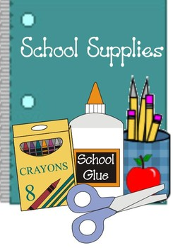
1 each Exercise book – plain, 72 page
1 each Ruler (cm) clear, rigid, starting with zero
1 set Headphones
1 pair Indoor Shoes (suitable for gym use)
1 each Communication/Courier Bag (15” X 10.2”)

